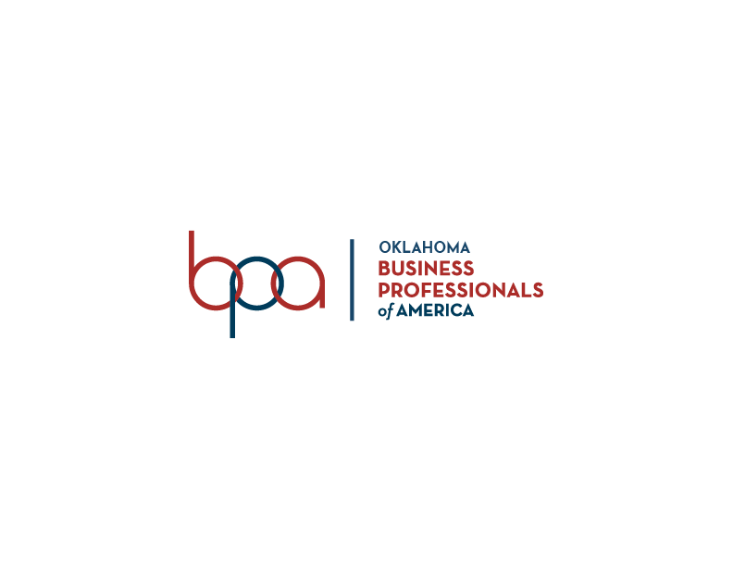

2022 Merit Scholar Study Guide
Business Professionals of America, Oklahoma Association is a co-curricular Career Technical Student Organization (CTSO) best suited for students enrolled in business management, information technology, finance, office administration and other related career fields.
State Level

Oklahoma BPA, which is headquartered in Stillwater, OK was chartered in 2001. Paxton Cavin is the current State Advisor and is responsible for serving individual members and local chapters. Follow us on social media: Twitter @OklaBPA, Facebook, and/or Instagram @oklabpa.

The State Administrative staff includes:
- Carrie DeMuth, State Program Administrator
- Kathy Orr, Business Management & Administration Program Specialist
- Paxton Cavin, Marketing Program Specialist, State BPA & DECA Advisor
- Kristi Lofton, IT Program Specialist
- Mark Burch, Marketing & Finance Program Specialist
- Pamela Porter, Administrative Assistant

The 2021 – 2022 BPA State Executive Council:
- President – Brighton Snow
- State Vice President – Adriel Lora
- State Vice President – Dillon Henry
- State Reporter – Hallee Schonfield
- State Historian / Chaplain – Brannon Watts
- State Secretary – Keeli Cope
- State Parliamentarian – State Parliamentarian
- Mid-Level Representative – Vacant

Community Service Project
Special Olympics is the state and national BPA community service project. In Oklahoma, the top 3 schools raising the most money for Special Olympics receive a plaque at Fall Leadership Conference through the “Chain of Love” project.

Important Dates:
- October 18, 2021 – Fall Leadership Conference, Norman, OK (Theme: Noteworthy)
- March 7-9, 2022 – State Leadership Conference, Tulsa, OK (Theme: Together we Strive)

Other Resources to Review:
- Oklahoma BPA: http://bpaok.org/
- Oklahoma Bylaws: http://bpaok.org/about-us-2/

National Level

The National Center is located in Columbus, Ohio. The official website iis www.bpa.org.

Mission Statement
Our mission at Business Professionals of America is to develop and empower student leaders to discover their passion and change the world by creating unmatched opportunities in learning, professional growth, and service.

Vision Statement
To be an innovator in Career and Technical Education, providing our members with opportunities for growth through education, competition, community service, and personal development.

BPA Pledge
“We are met in a spirit of friendship and goodwill as we prepare for careers in a world-class workforce. We work together to develop professionalism and leadership through Business Professionals of America and pledge our loyalty to our nation.”

Business Professionals of America’s Name
- Business: The field for which we prepare our students; emphasizes that we educate our members to work efficiently, not only in an office setting, but also in a wide variety of business situations.
- Professionals: Our students indicate they join BPA to take advantage of a wide variety of professional development opportunities.
- America: Symbolizes pride in our country and its free enterprise business system.

Official Tagline
The official tagline is “Giving Purpose to Potential”

Branding Refresh: https://bpa.org/blog/2019/04/29/brand-refresh/

Official BPA Colors
- Navy Blue: signifies the success achieved through leadership and professionalism.
- Tan: represents the bountiful fields of opportunity in America.
- Red: symbolizes the friendship obtained through teamwork in our organization.

The Emblem
The four points of the BPA shield stand for Ambition, Leadership, Sociability, and Poise. The shield itself stands for honor and dignity and the importance of business in America. The stripes represent education, citizenship, loyalty, patriotism, competency, and dependability. The bar represents the service provided by employees in business occupations. The quill and inkwell represent the stability of business occupations through the ages, and the torch represents worthy goals.

Use of the Acronyn
Using an acronym (BPA) to identify the organization is acceptable in casual conversation and personal correspondence. Once the name is spelled out in full, the acronym may be used in text. Do not use the acronym for cover titles or headlines.

BPA Attire
- The official BPA blazer is navy blue and has the logo on the left side
- The nametag is worn on the right side of the jacket.
- The highest torch award pin earned is placed on the right lapel.
- The national merit pin is placed on the right lapel.
- The year membership pin is placed on the left lapel.
- The officer pin is placed on the right lapel above the nametag

National Leadership Conference and Theme
The 2020 NLC was in National Harbor (Washington DC Area), May 6-10, 2020. “Capitalize your Future” was the conference theme.
The 2022 NLC will be in Dallas, TX, May 4-8, 2022. “Go Beyond your Limits” is the conference theme.

Torch Awards Program
BPA’s Torch Awards Program recognizes BPA members for community service and for leadership development activities. There are nine torches in seven activity divisions. The torches are leadership, service, cooperation, knowledge, friendship, love, hope, faith, and patriotism. Torch Awards Handbook: https://34kjmn3xy614nqsp3bsgpb13-wpengine.netdna-ssl.com/wp-content/uploads/2019/09/Torch-Handbook-2019_20_Release_9-1-2019.pdf

- Local Award Executive 10 points per category
- Regional Award Diplomat 30 points per category
- State Award Statesman 50 points per category
- National Award Ambassador 70 points per category

BPA Cares
This award program allows students to receive recognition at the state and national levels for engaging in worthwhile projects. BPA Cares is divided into three categories with 18 different awards https://bpa.org/students/bpa-cares/

- Service Learning Awards Program (5 awards) – Community Service Award, Environmental Action/Awareness Award, Safety Awareness Award, Service Learning Individual Award, and Special Olympics Award
- Special Recognition Awards Program (7 awards)– BPA Marketing and Public Relations Award, BPA Merit Scholar Award, Chapter Activities Award of Excellence, Member Recruiter of the Year Award, Membership Explosion Award, Social Media Award, and the Professional Cup Award.
- Professional Awards Program (6 awards) – Advisor of the Year Award, Emerging Advisor of the Year Award, Emerging Professional of the Year Award, Student of the Year, Hall of Fame Award, and Outstanding Service Award.

Workplace Skills Assessment Program (WSAP)
Competitive events occur at the regional, state, and national levels. The events test a member’s competency in six categories (listed below). Members may also compete in Virtual events (nine events are available).
- Finance
- Business Administration
- Management Information Systems
- Digital Communication & Design
- Management, Marketing & Communication
- Health Administration
Secondary (high school) and Middle-Level (middle and junior high school) BPA members registered for State Leadership Conference may compete in two events, excluding open events, which are unlimited. Post-secondary (adult) members may compete in three events. Learn more by visiting http://bpaok.org/compete/

The Wire
The official online magazine for BPA that includes local and state association news, activities, programs, professional development, blogs, and current business trends.

Webinars
BPA Webinars are offered monthly online to students and advisors. Webinars are designed to train, inform, and gather feedback.

Social Media
BPA social media is designed for up-to-the-minute news flashes targeting advisors and students. The National Officer Team utilizes social media to encourage direct student participation in decision-making opportunities.
- Facebook: https://www.facebook.com/businessprofessionalsofamerica
- Twitter: @National_BPA Instagram: bpanational
- Snapchat: @national_bpa
- LinkedIn: Business Professionals of America

Student Certification Series
The Student Certification Series is an online certification program led by the National Officer Team that teaches members general and key information about Business Professionals of America. Visit https://bpa.org/students/student-certifications/

The SOURCE
The SOURCE is a BPA online, interactive community dedicated to Advisors, classroom resources and chapter resources.

Miscellaneous
- Business Professionals of America Week is a great opportunity to promote local chapters. It is the second full week of February in coordination with Career and Technical Education month.
- Business Professionals of America is a not-for-profit association.
- Membership dues must be paid by February 15 to compete at the national level.
- BPA has four divisions: Middle-Level, Secondary, Post- Secondary, and Alumni.

Other Resources to Review:
BPA History: https://bpa.org/about-us/our-history/

BPA Traditions: https://bpa.org/about-us/our-culture/

BPA Membership: https://bpa.org/about-us/our-footprint/

Governance
- The Board of Trustees provides oversight to the creation, direction, and supervision of the activities of Business Professionals of America. The secondary and post-secondary presidents serve as voting members of the board. The chairperson is Dr. Brenda Jacobsen.
- The State Association Advisory Council (SAAC) is comprised of the State Association Advisors, the council advises the Board of Trustees on all State Association matters.
- The Classroom Educators Advisory Council (CEAC) consists of local advisors from each state appointed to serve as a liaison between the chapter advisors and the Board of Trustees. The council recommends changes and/or additions to theWorkplace Skills Assessment Program and other programs.
- The National Business Advisory Council (NBAC) provides a liaison between business and industry and the Board of Trustees.

Parliamentary Procedure and BPA By-laws
- In order for voting to take place, a quorum must be present. A quorum consists of a majority of voting delegates.

- The Current edition of Roberts Rules of Order Newly Revised will govern Parliamentary Procedure of all meetings.

- The five types of motions are Privileged motions, Subsidiary motions, Main motions, Incidental motions, and motions that bring the question again before the assembly.

- The Bylaws were adopted in April 1989 and last amended July 21, 2019.

- Bylaws may be amended by two-thirds vote of the voting delegates at the National Leadership Conference, if:
- The amendment has been presented in writing by the state association proposing the amendment to all state associations of Business Professionals of America, the Business Professionals of America Executive Director, and the national president on or before December 15 preceding the National Leadership Conference;
- The Executive Director and National President are responsible for making the proposed amendment known immediately to the Executive Council who must consider the proposed amendment during their next meeting;
- The Executive Council has approved the amendment and the Executive Director has presented the proposed amendment to the Board of Trustees of Business Professionals of America, Inc. no less than sixty (60) days prior to the National Leadership Conference; and
- The Executive Director has announced its approval by the Executive Council and presentation to the Board of Trustees to each state association and has posted the proposed amendment on the Business Professionals of America web site no less than thirty (30) days prior to the National Leadership Conference.

