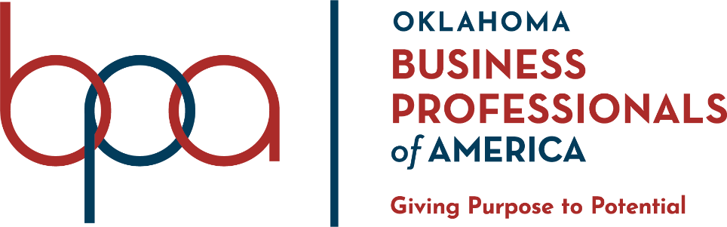

SLC 2022 Conference Agenda – Tulsa, Oklahoma

Sunday, March 6, 2022
5:00PM – 7:00 PM
Early Bird Registration – Hyatt Regency, 2nd floor

Monday, March 7, 2022
7:00 AM
Registration & Information Desk Opens – Hyatt Regency 2nd floor
9:00 AM
Competition at Tulsa Technology Center Peoria Begins
1:00 PM
Grading Room Opens – Hyatt Regency, 1st floor
7:00 PM
Opening Session | Keynote Speaker | Campaign Speeches – Cox Convention Center
(Venue doors open at 6:00PM, theater doors open at 6:30PM)

Tuesday, March 8, 2022
7:00 AM
Registration & Information Desk Opens – Hyatt Regency, 2nd floor
9:00 AM
Competition Begins – Hyatt Regency, 1st & 2nd floors
9:00 AM
Grading Room Opens – Hyatt Regency, 1st floor
9:00 AM
Campaign Booths & Vendor Booths Open, Hyatt Regency, 1st floor
3:00 PM
Campaign Booths & Vendor Booths Close
*4:00 PM*
*tentative time for business meeting (voting delegates) – Hyatt Regency*

Wednesday, March 9, 2022
9:00 AM
Grand Awards Session| Officer Farewell| & Election Results – Cox Convention Center
(venue doors open at 8:00AM, theater doors open at 8:30AM)

