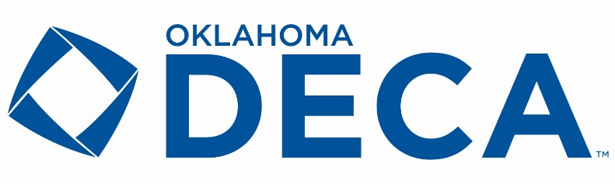

Fall Leadership Conference Agenda

October 15th – Set Up Day

5:30 – 6:30 PM
Early Bird Check In – Get a head start on conference by picking up your registration materials early. This is a great option for those advisors staying overnight in Norman.

October 16th – FLC Day

7:00 – 8:00 AM
Check In & Registration Packet Pick Up – pick up conference materials, browse the FLC store, and network prior to the workshops beginning.

8:15 – 9:00 AM
Leadership Session 1 – A list of workshops will be released prior to conference.

9:05 – 9:50 AM
Leadership Session 2 – A list of workshops will be released prior to conference.

10:00 AM
Pin Voting CLOSES – Vote for the pin you think best represents Oklahoma DECA!

9:55 – 10:30 AM
Officer Workshops & Advisor Updates – A list of workshops will be released prior to conference.

10:45 AM – 12:00 PM
General Session, Keynote, & Awards – Get ready to officially meet your state executive council, hear about the afternoon session, and learn about life and leadership from our keynote speaker.

12:00 – 1:30 PM
Lunch – Concession stand available at conference center and restaurants in the area – plan ahead to make the most of this time!

1:30 – 2:30 PM
Leadership & Community Service – We will have several onsite, hands on community service options and leadership activities available. You can participate individually or as a chapter.

