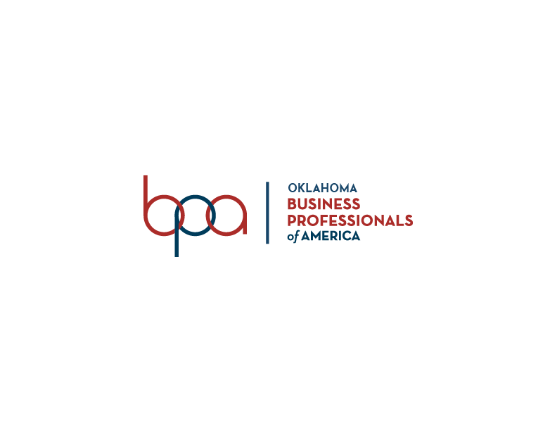

Merit Scholar Study Guide
Business Professionals of America, Oklahoma Association is a co-curricular Career Technical Student Organization (CTSO) best suited for students enrolled in business management, information technology, finance, office administration and other related career fields.

Oklahoma BPA, which is headquartered in Stillwater, OK was chartered in 2001. Paxton Cavin is the current State Advisor and is responsible for serving individual members and local chapters. Follow us on social media: Facebook, and/or Instagram @oklabpa.

The State Administrative staff includes:
- Mark Burch, State Program Administrator
- Ronda Hill, Business Management & Administration Program Specialist
- Paxton Cavin, State BPA & DECA Advisor
- Kyla Hensley, IT Program Specialist
- Jake Phillips, Marketing & Finance Program Specialist
- James Gordon, Administrative Assistant
- Rose Devers, CTSTO Bookkeeper
- Emily Barrett, Part Time Clerk

Community Service Project
Special Olympics is the state and national BPA community service project. In Oklahoma, the top 3 schools raising the most money for Special Olympics receive a plaque at Fall Leadership Conference through the “Chain of Love” project.

Other Resources to Review:
- Oklahoma BPA: http://bpaok.org/
- Oklahoma Bylaws: http://bpaok.org/about-us-2/
- National BPA: www.bpa.org

Who to know:
- The current state advisor of OK BPA
- The state director of Oklahoma Careertech
- The executive director of BPA
- The current state officer team
- The current executive (national) officer teams
- The Oklahoma advisor of the year

BPA Knowledge to know:
- Which purposes of the State BPA organization are in the Oklahoma BPA bylaws
- Which award program allows chapters and students to receive recognition at the national and state level
- How many events secondary members can compete in at SLC, excluding open events
- What year the original club founded BPA
- What year Oklahoma secured a national BPA charter
- What year the newest BPA logo was released
- Which career field is not part of BPA and its co-curricular plan
- What organization that OK BPA supports regarding community service projects
- Where the OK BPA state headquarters is located
- Where the National Center for BPA is located
- Which state has the largest post-secondary division membership
- When BPA week is celebrated
- Which office is traditionally appointed to the SEC instead of being elected
- Who sponsors several of the 300 level events
- The mission of BPA
- How many voting delegates is needed with up to 50-chapter members to have at SLC
- The number of votes required to amend the state bylaws at SLC
- How many days amendments to the OK BPA constitution must be published and circulated before the voting at SLC
- The names of the torches of the Torch Award Program
- What CEAC stands for
- What the colors of the emblem stand for
- The four points of the BPA emblem and what they stand for
- How many points in each category are needed to earn the torch award
- The name of the state torch award
- How many members are on the national board of trustees
- Where the BPA nametag should be worn

Fast Facts to know:
- What is the color of the official BPA blazer?
- Where you can find the WSAP of the current year?
- How money was raised for our community service project at FLC?
- What is the site of SLC?
- What state design is voted for at FLC?
- What was the current year’s FLC theme?
- What is the correct tag line in its proper form?
- What was the site of FLC?
- Which categories of competitive events are held at the OK BPA SLC?
- What are the locations that are common for NLC sites every year?
- Which division is represented in Oklahoma BPA?
- Which publication currently governs Parliamentary Procedure of all BPA meetings?
- How much Oklahoma BPA dues are?
- How many states BPA is represented in?
- What is the official OK BPA website?
- What the current BPA SLC theme is?

