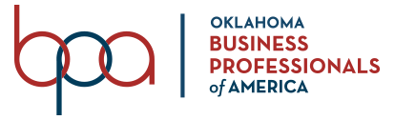

**BPA Monthly Meeting January 24, 2022**

9:00 AM | Professional Dress

Location: Stillwater, OK

**Meeting Agenda**

Call to Order - Makayla, President

Role Call & Determination of Quorum - Maggie, Secretary

Inspiration - Natalie

Membership Update - Thomas

Social Media Update - Madalynn

Photo Session - Group & Individual

SLC Planning - All

* Oklahoma Recognition Awards
* Conference agenda and expectations
* Questions

CTSO Day at the Capitol

New Business

Adjourn